Computer in Past
The first computers were very large, expensive and slow compared to modern computers. They were mainly used for scientific calculations, military purposes, and research. Early computers occupied entire rooms and consumed a lot of electricity. They had limited storage and processing power.
Examples:
1 ENIAC: one of the earliest general purpose electronic computers.
2 UNIVAC I: an early commercial computer used for business and government.

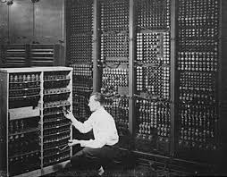
Computer in Present
Today, computers are much smaller, faster, and more powerful. We use computers in education, business, banking, hospitals, communications, entertainments, and many other fields. Laptops, desktops, tablets, and smartphones allow peoples to access information and communicate easily. Modern computers can also use artificial intelligence and store huge amounts of data.
Examples:
1 Desktop computers: used in offices, schools and home.
2 Laptops: used for studying, working, programming and entertainment, etc.
3 Artificial Intelligence powered computers: it helps with tasks such as writing, data analysis, image generating as well as problem solving, etc
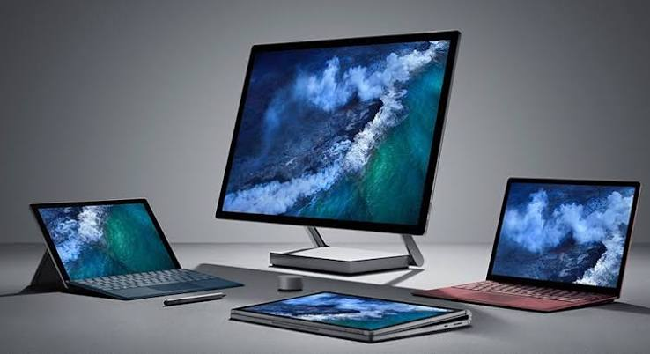

Computer in Future

In the future, computers are expected to become even faster, smarter, and more advanced. Artificial Intelligence, robotics, cloud computing, may play a major role. Computers may become more connected with everyday life and help peoples solve complex problems in science, education, medicine and technologies.
Examples:
1 Quantum computers: It may solve certain complex problems much faster than conventional computer.
2 AI computers: It may perform more tasks automatically and intelligently.
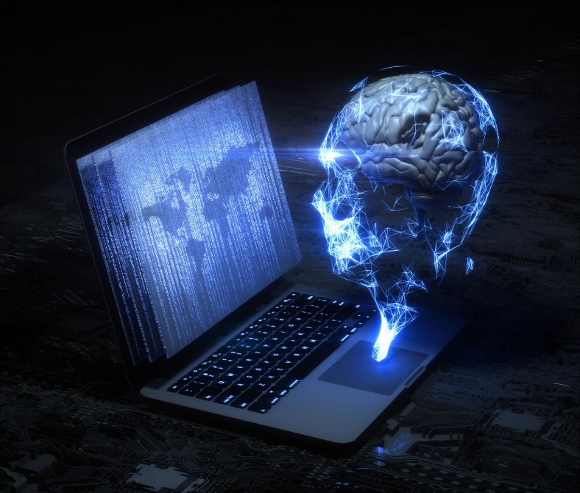
Conclusion: Computers have developed from huge machines in past to powerful portable devices today. In the future, computers will continue to become more advanced and may play even greater role in our daily lives.

Submitted by: Aditi Palel

